//Creating the class for moviegoers to allow for multiple types, i.e. adults, seniors, kids, etc.

class MovieGoer
{
private $_age;
public function setTktPrice ($age) {
$this->_age = $age;
}

//Now instantiate the objects for each of the “types” of ages for the price schedule
$senior = new MovieGoer ();
$adult = new MovieGoer ();
$kid = new MovieGoer ();
$toddler = new MovieGoer ();

$senior->echo “That will be $8 please”
$adult->echo “That will be $10 please”
$kid->echo “That will be $5 please”
$toddler->echo “Toddlers under age 5 are free to enter”

//An ALTERNATIVE DESIGN may need to specify the amount of the ticket price as a variable, especially if the program was going to be used for anything like calculating the bundle of ticket purchases e.g. or else chnging the dicounts offered or allowing discounts to apply to multiple groups etc. However given the instructions of the assignment the purpose I interpreted it to mean was simply separating objects and classes for each of the group and display the movie ticket price...at which point let the group attending the movie figure out how much the total is for what they owe.

//Still a very fun project and should be something that I can put to use too soon I hope.

/*
NOTES:
More helpful examples to try out for the OOP stuff

Objects
<?php
$myPage = new Html;
// Creates an instance of the Html class
$myPage->printLn('This is some text');
// Prints "This is some text&lt;br /&gt;"
?>
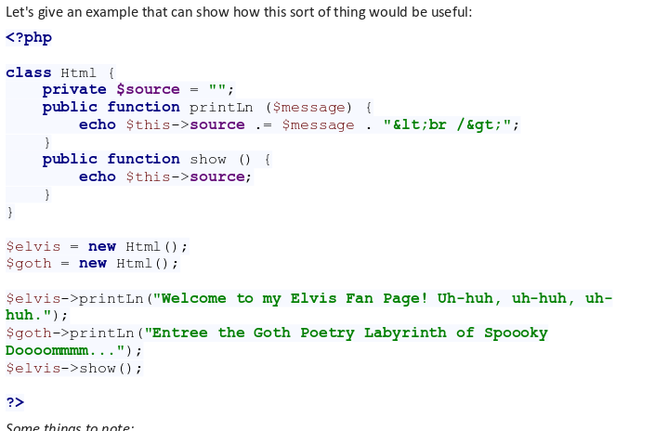

INHERITANCE AND EXTENDING CLASSES (probably good for another module/topic)

//CLASS CONSTRUCTOR (IN PHP)...LESSON FOCUS
<?php
class Person
{
private $_name;
private $_age;

function __construct($name, $age = 0)
{
if (!is_int($age))
{
throw new Exception("Cannot assign non integer value to integer field, 'Age'");
}
$this->_age = $age;
$this->_name = $name;
}
}
?>

//CONSTRUCTOR OVERLOADING…..TBD
<?php
class BankAccount{
private $accountNumber;
private $totalBalance;
public function __construct(){
}
public function __construct($accountNo){
$this->accountNumber = $accountNo;
}
public function __construct($accountNo, $initialAmount){
$this->accountNumber = $accountNo;
$this->totalBalance = $initialAmount;
}
}
?>

//ENCAPSULATING…..asking for user input and then validating it...useful for above code
public function setAge($age) {
if (!is_int($age))
throw new Exception(“Cannot assign non integer value to integer field, ‘Age’”);
$this->_age = $age;

}
*/

